**Title**

**Abstract**

**Introduction**

**Methods**

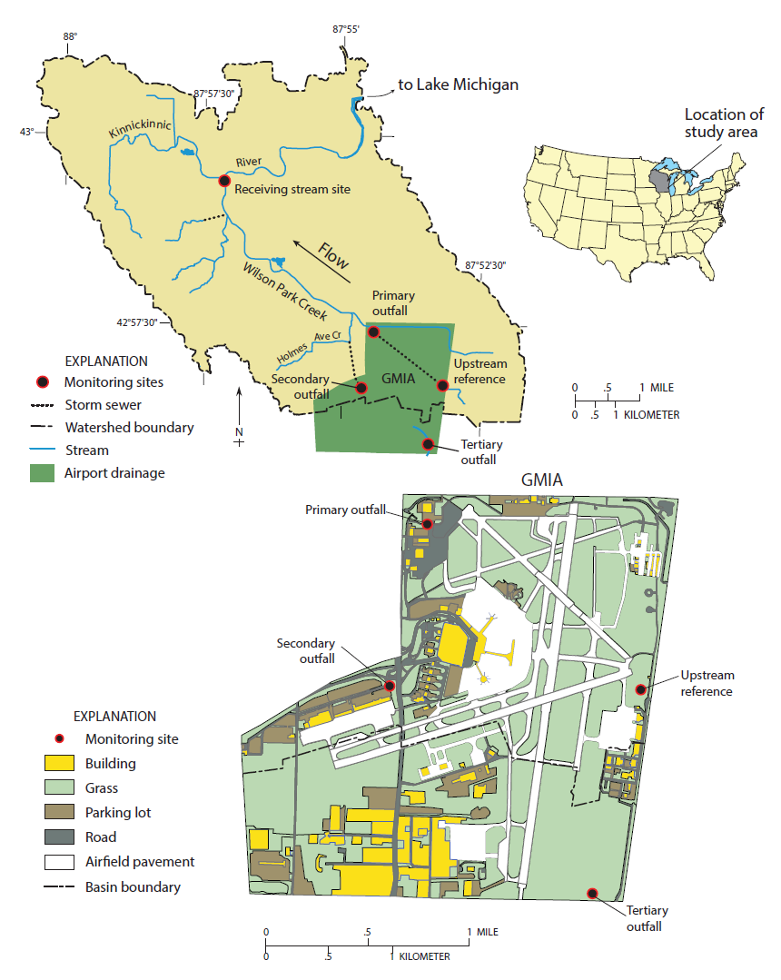

**Figure 1.** Location of field study area and monitoring locations

*Site Description*

Surface water samples were collected at five locations near General Mitchell International Airport (GMIA) over two winter seasons from December 2013 – March 2015; an upstream reference, three airport outfalls (a primary, secondary and tertiary), and a receiving stream location (Fig. 1). In total, 144 precipitation runoff event samples were collected from the five sampling locations with some sites having greater collection frequencies than others (Table 1). The upstream reference location consists of a 2.31 km2 headwater region of Wilson Park Creek (WPC) which primarily drains an urban area in addition to a small portion of runway before airport runoff enters the system (Figure #, GMIA and sample location figure). There is potential for a small amount of airport and deicer runoff to reach the upstream location from the deicing activities of the Wisconsin Air National Guard which is located within close proximity to the upstream reference site. Two airport outfall locations were sampled and drain to WPC. The primary outfall location includes flow from the upstream reference location in addition to flow from the storm sewers draining the terminal area as well as some taxiways and runways. The secondary outfall drains a small area of the airport where most air cargo activities take place. The secondary outfall discharges into Holmes Ave. Creek, a small tributary of WPC, which at the confluence is ~ 0.8 km downstream from the primary outfall. Drainage area of the primary outfall is 5.83 km2 (3.52 km2 representing the airport facility) while the drainage area of the secondary outfall is 0.08 km2. The fourth location is situated 5.54 km downstream from the airport. This site was chosen in order to characterize water quality effects on the receiving stream. The stream between the airport and the receiving stream location alternates between concrete-lined and earthen channel bottom. The drainage area of the receiving stream location (i.e. WPC) is 14 km2. Immediately beyond the receiving stream location, the stream confluences with the Kinnickinnic River, which flows for 4.33 km to the Kinnickinnic River estuary and eventually into Milwaukee Harbor. The fifth location, tertiary outfall, flows south out of GMIA and was used to collect grab samples only. As GMIA has grown over the years, airport operations (i.e. runways, taxiways, etc) have moved into the tertiary outfall watershed and samples were collected to determine the influence of aircraft deicer materials leaving airport property via this outfall. Samples collected from the tertiary outfall were grabbed at roughly the same location; where the stream intersects with W. College Ave, prior to any confluence with additional water sources. The tertiary outfall eventually drains to Oak Creek which discharges directly into Lake Michigan.

*Surface-Water Sampling*

Flow-weighted water quality samples were collected using refrigerated automatic samplers with Teflon-lined polyethylene sample tubing and 10L glass collection bottles (model 3700R, Isco Industries, Lincoln, NE). In addition to the 10L glass collection bottle above, the primary outfall location collected flow-weighted water quality samples into 350 ml glass collection bottles (model 3700R, Isco Industries, Lincoln, NE). Additional specific details regarding the sampling protocol have been previously described 1. Various bottle collection types and numbers of samples were collected from the five monitoring locations (Table 2). After each runoff period, or sampling period, samples were collected, iced and then transported to the Middleton, WI U.S. Geological Survey field office for processing. Samples were subsequently split for separate chemical and optical analysis, filtered (if required), preserved (if required), iced and delivered to the laboratory within 24 h. Constituents reported in this paper include propylene glycol, ethylene glycol, acetate, chemical oxygen demand (COD), absorbance and dissolved organic carbon (DOC). Field blanks were collected at each of the five locations and samples were submitted for all constituents listed above.

*Chemical Analysis*

All chemical analyses, except DOC and absorbance, were conducted at the Wisconsin State Laboratory of Hygiene (WSLH). Acetate was analyzed using methods as defined in the manual for the DIONEX AS15 separator column (DIONEX, Sunnyvale, CA). Additional details regarding DIONEX instrument conditions was previously described 2. Reporting levels were determined as the concentrations below which spike recoveries exceeded 25% uncertainty (5 mg/L for acetate). Samples for acetate were filtered (PALL, Acrodisc ® 0.2 µm nylon membrane, 25 mm capsule syringe filter) into one 40 ml plastic bottle. Samples collected for glycol were filtered (Whatman, 0.2 µm CA filter media, 25mm polypropylene capsule syringe filter) into two individual 40 ml plastic bottles. Raw surface water for COD samples was preserved with 1.0 ml of a 1 to 3 sulfuric acid solution in a 250 ml plastic bottle prior to delivery to WSLH. Methods for the analysis of propylene and ethylene glycol and COD have been previously published 3,4.

Troy to gather blank and replicate data for WSLH field QA/QC. (possibly have Troy gather MSDS sheets).

*Dissolved Organic Carbon (DOC) and Optical Analysis*

Environmental samples for DOC and optical analyses were filtered (Whatman® glass microfiber syringe filters, pore size 0.45 µM) into two pre-combusted 40 ml amber glass vials. Deicer and anti-icer products (Table ##) were unfiltered and analyzed for DOC and optical analysis. For both DOC and optical analysis of the deicer and anti-icer products, serial dilutions were performed to get the samples in range for both analytical instruments. Both sample vials were stored in the dark at 4 °C until sample analysis. All samples for DOC and optical analysis were analyzed within 5 days of collection.

DOC samples were analyzed using a Shimadzu TOC-VCSH analyzer, which employs a catalyst-aided platinum 680 °C combustion technique, coupled with the Shimadzu ASI-V Auto sampler. The non-purgeable organic carbon (NPOC) analysis method was employed, in which samples were sparged with 2 M HCL to remove all inorganic carbon prior to combustion. The resultant NPOC concentrations, given in units of mg/L, were calculated as a mean of three valid measurements with a maximum standard deviation of 0.1 mg/L. Based on long-term monitoring of blank concentrations from ultra-pure 18.2 megohm water, method detection limit (MDL) for the Shimadzu system is 0.2 mg/L.

A fluorescence excitation-emission matrix (EEM) and absorbance scan measurements were performed using a Jobin Yvon Aqualog benchtop spectrofluorometer. EEMs were generated using excitation (ex) wavelengths of 240 – 800 nm at intervals of 3 nm and emission (em) wavelengths of 247 – 827 nm at intervals of 2.33 nm with an integration time of 1 s and a CCD gain set at medium. Absorbance and fluorescence analysis were performed in a 1-cm path-length quartz cuvette. Samples were diluted with ultra-pure 18.2 megohm water and re-run if UV-Visible absorption data at 254 nm (A254) exceeded 0.3 absorbance units to limit inner filter effect problems 5. Spectra were corrected for inner filtering effects, Rayleigh 1st and 2nd order masking using automated algorithms supplied with the Aqualog software. Fluorescence intensity was normalized to a Starna (Starna Cells, RM-QS00) certified quinine sulfate standard. All samples were blank corrected against a Starna (Starna Cells, 3Q-10) certified Raman calibration standard.